DriverPass System Design Document
CS 255: Systems Analysis and Design
Project Two: System Design Document
Uchenna Nwaogbe

UML Use Case Diagram
The use case diagram below was originally developed in Module Six and reviewed against the DriverPass business requirements document for this project. No adjustments were needed: the diagram accurately reflects the five actors identified for the system (Customer, Secretary, Driver, Administrator, and the external DMV system) and the fourteen use cases drawn from the functional requirements, including account registration and login, package purchase, lesson scheduling and modification, practice testing, driver notes, activity reporting, package management, and DMV record updates.
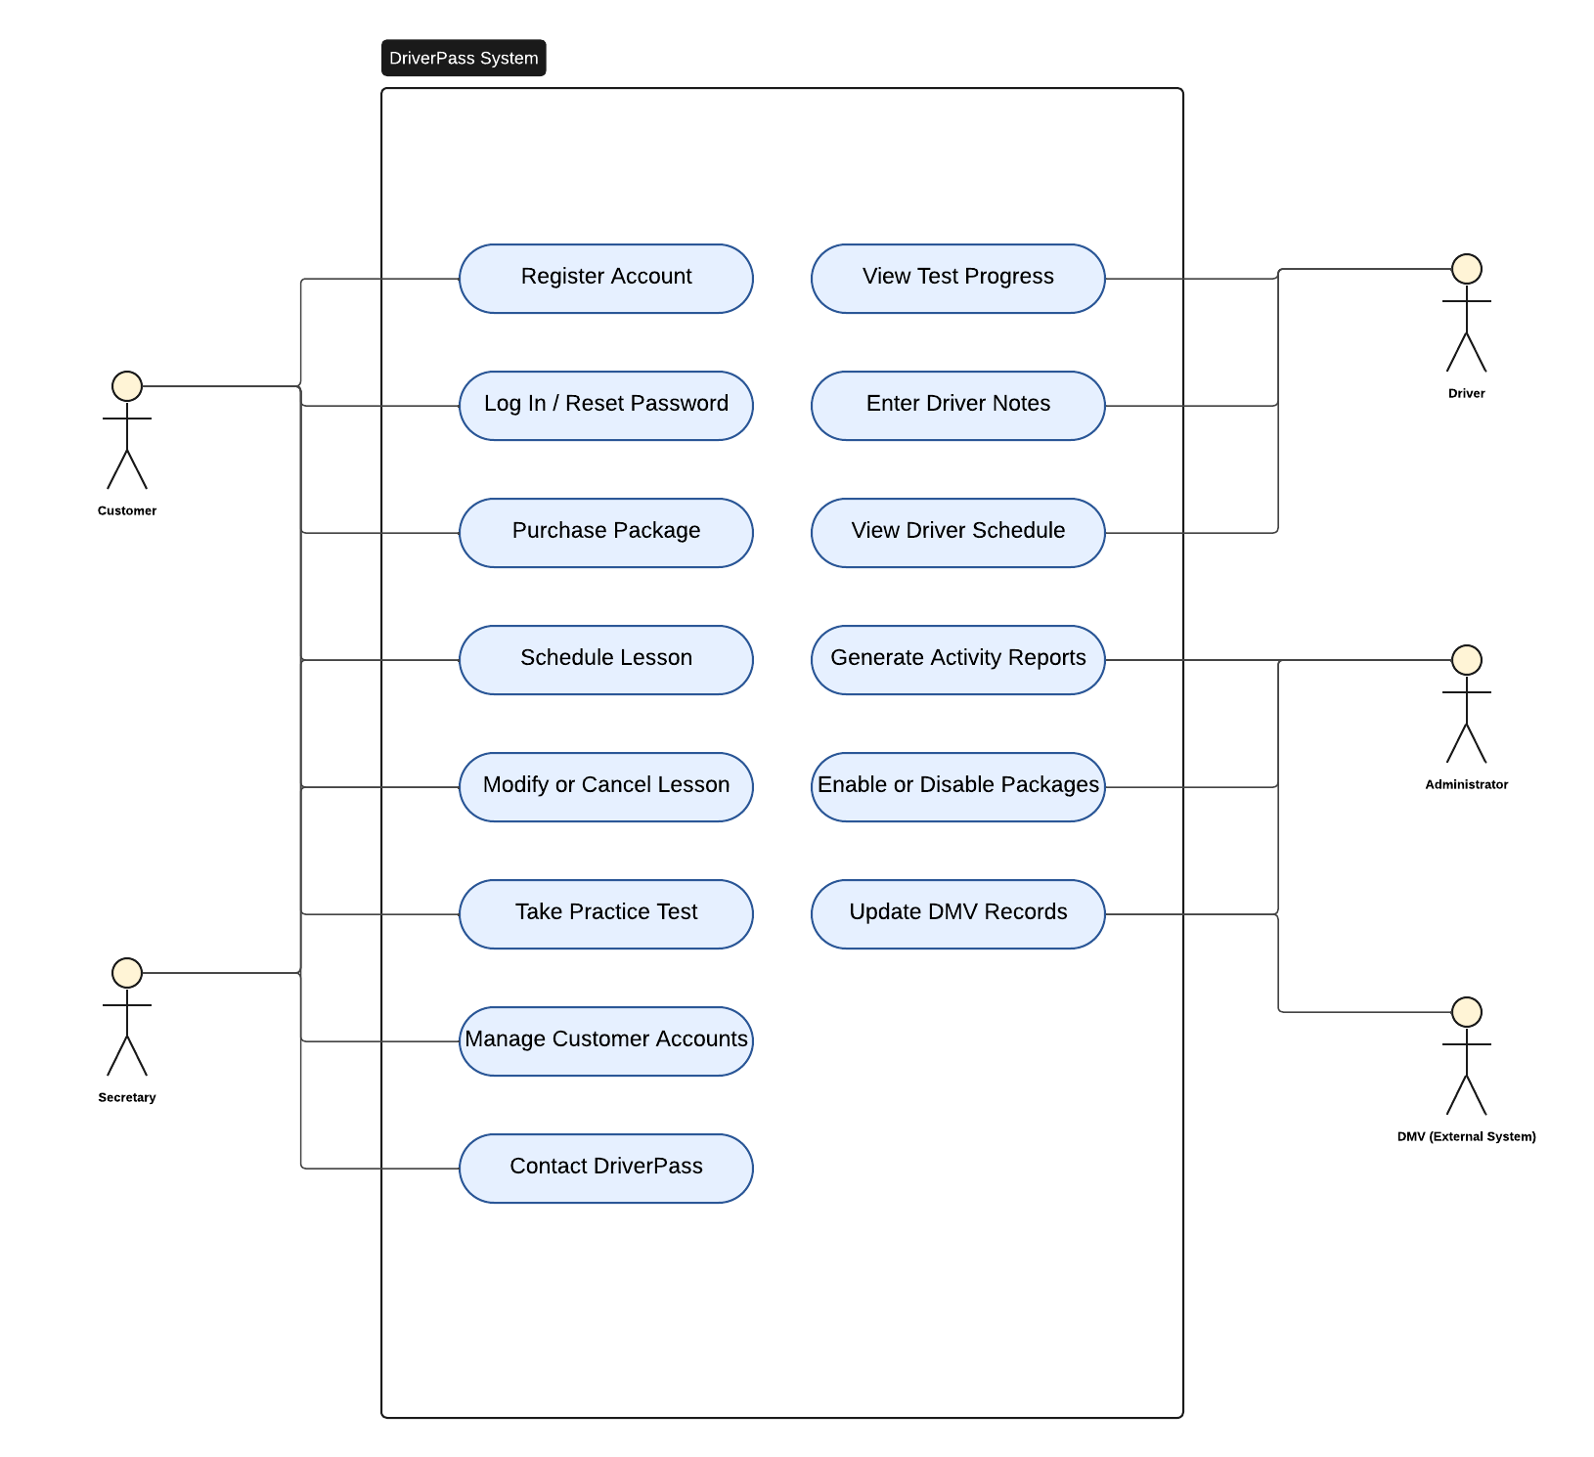

UML Activity Diagrams
Two use cases were selected for activity diagrams: Schedule Lesson and Take Practice Test. These were chosen because they involve the most decision logic in the system and are central to the client's day-to-day operations.
Schedule Lesson walks through how a customer books a driving lesson, including the two validation checks the system performs before confirming a reservation: whether the customer's package has enough remaining hours, and whether a driver and vehicle are available for the requested time.
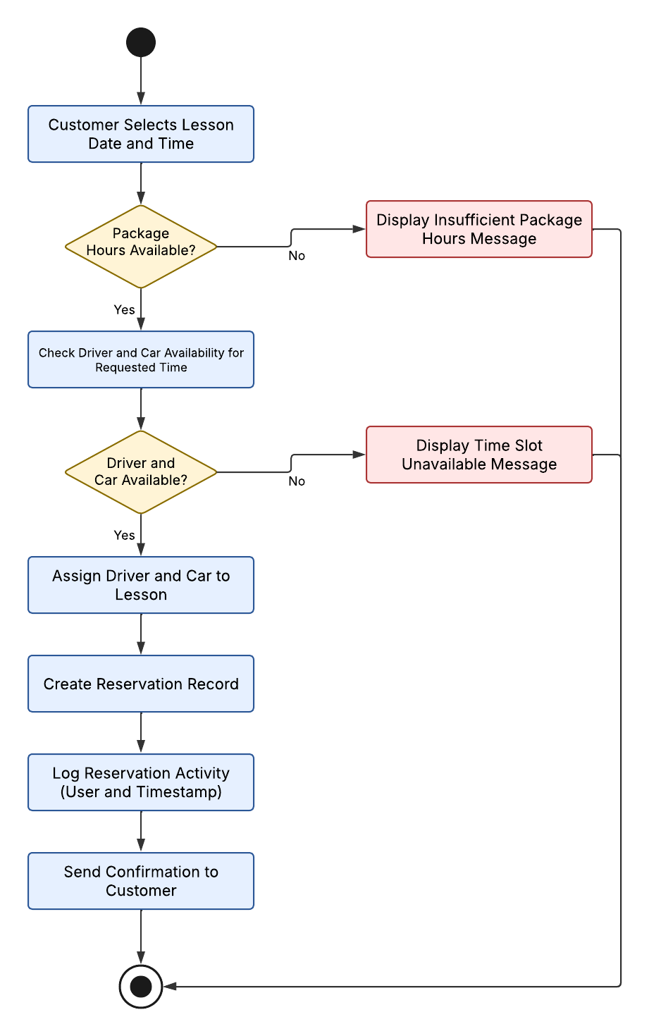

Take Practice Test walks through how a customer takes an online practice test, including the check for whether the customer's package includes online testing before the test is presented.
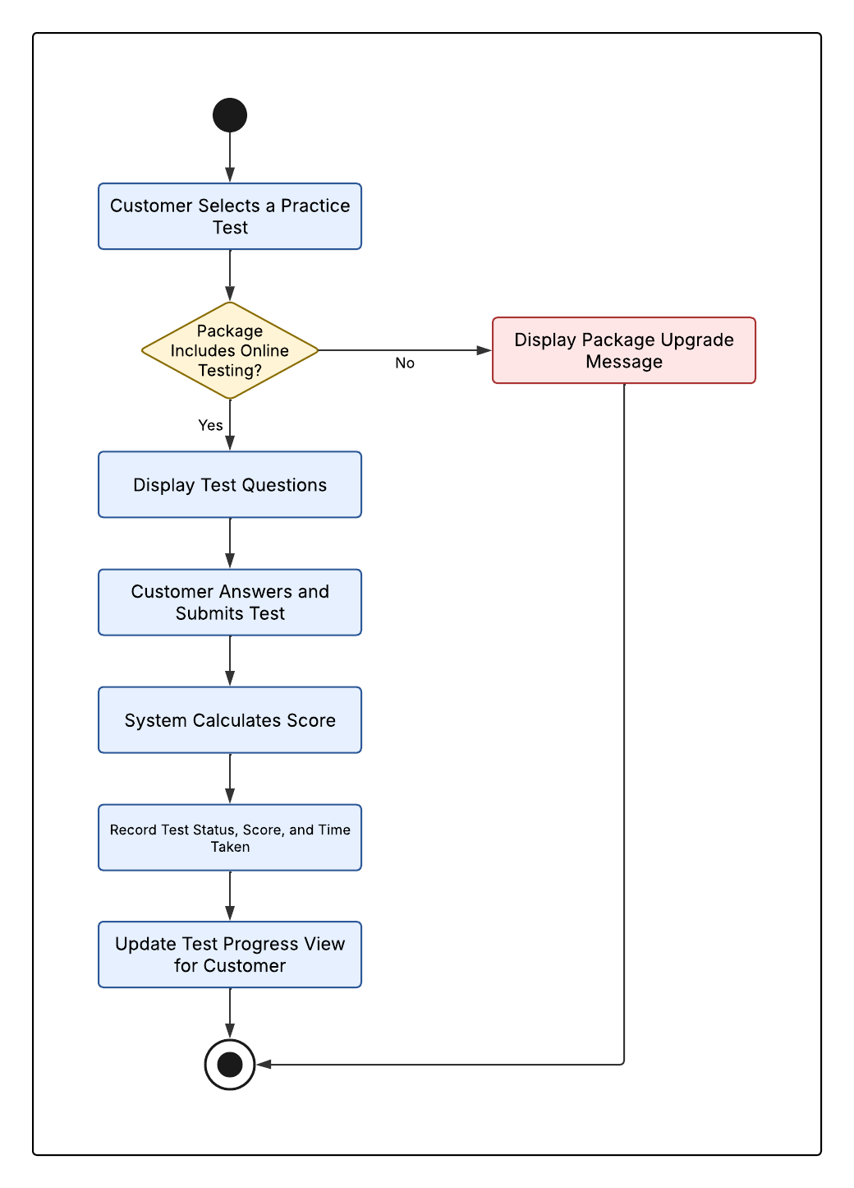

UML Sequence Diagram
The sequence diagram below illustrates the Schedule Lesson use case, showing the interaction over time between the Customer, the DriverPass System, and the Database as a lesson request is validated and a reservation is created. It mirrors the decision logic shown in the corresponding activity diagram, but focuses on the messages exchanged between the customer, the system, and the data layer.
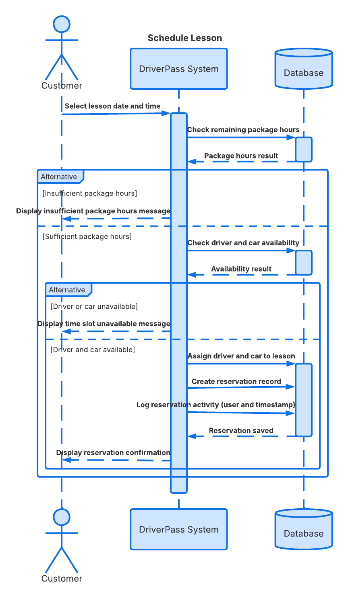

UML Class Diagram
The class diagram below defines the classes and attributes needed to support the DriverPass system. An Account class holds shared login and security attributes (username, password hash, role, and lockout tracking) and is specialized by Customer, Secretary, Driver, and Administrator, reflecting the role-based account requirement from the business requirements document. Package, Reservation, Vehicle, and PracticeTest model the core business data, and ActivityLog supports the system's activity-logging and reporting requirements. Multiplicities on each association show, for example, that one customer can have many reservations and many practice test attempts, and that one reservation is linked to exactly one package, one vehicle, and one driver.
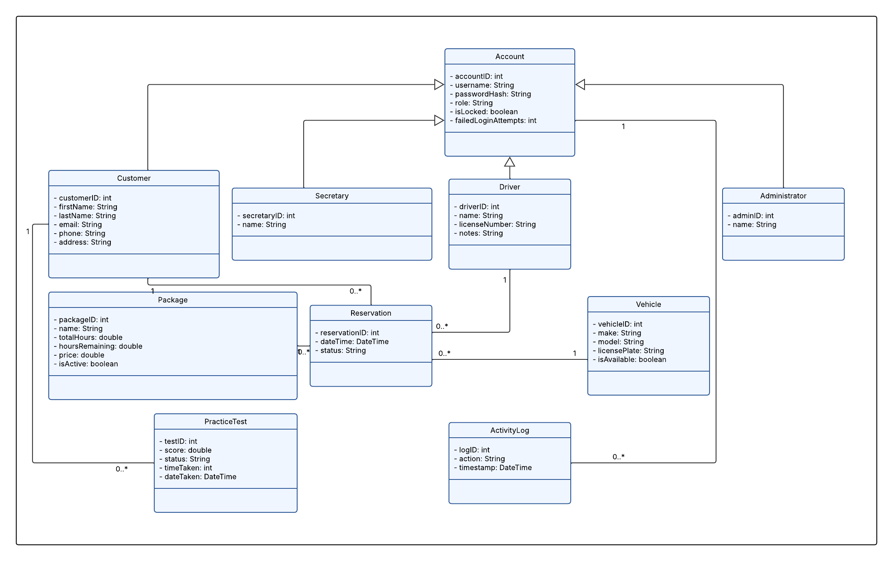

Technical Requirements
The technical requirements below are drawn directly from the functional and nonfunctional requirements identified in the Project One business requirements document, and are shaped by the structure shown in the diagrams above.

Hardware
Because DriverPass is a cloud-hosted web application, customers, the secretary, drivers, and the administrator only need a device with a modern web browser and an internet connection; a desktop, laptop, tablet, or smartphone with no special hardware or installed software required on the client side. On the server side, DriverPass needs cloud-hosted application server(s) and a cloud-hosted relational database server, provisioned with enough processing power, memory, and storage to support concurrent scheduling, reporting, and practice-test activity, along with built-in redundancy so the system stays available if a server fails.

Software
The system requires a web application built on a standard web framework, paired with a relational database management system to store accounts, packages, reservations, vehicles, driver notes, practice test results, and the activity log shown in the class diagram. The application must run in all major modern browsers (Chrome, Edge, Safari, and Firefox) so that every actor, customer, secretary, driver, and administrator can access it without installing anything. A reporting module capable of exporting activity and package data to Excel is needed to satisfy the requirement that the secretary be able to generate Excel-based reports.

Tools and Infrastructure
Security infrastructure must include HTTPS/TLS encryption for all data in transit, case-sensitive and securely hashed login credentials, automatic account lockout after repeated failed login attempts, and an automated password-reset workflow, directly supporting the security and accuracy requirements from the business requirements document. Role-based access control is needed so that Customer, Secretary, Driver, and Administrator accounts each see only the features appropriate to their role, consistent with the Account class hierarchy in the class diagram.
The system also needs a secure process for receiving DMV update notifications, scheduled database backups, and a logging and auditing subsystem that timestamps reservation and account activity for the secretary's and administrator's reporting needs. Finally, the development team will need a version-control system and a staging/testing environment to build, test, and deploy changes to the DriverPass system safely before they reach customers.

AI Usage Acknowledgment
Generative AI was used to assist in drafting the UML diagrams in Lucidchart and portions of the written content of this system design document, based on the Project One business requirements document and the Project Two assignment guidelines. All AI-assisted content was reviewed, verified, and edited by the student before submission.

